

Practices for Secure Software Report

Table of Contents
Document Revision History 3
Client 3
Instructions 3
Developer 4
1. Algorithm Cipher 4
2. Certificate Generation 4
3. Deploy Cipher 4
4. Secure Communications 4
5. Secondary Testing 4
6. Functional Testing 4
7. Summary 4
8. Industry Standard Best Practices 4

Document Revision History
Version | Date | Author | Comments
1.0 | 10/15/2025 | Yara Padilla

Client



Instructions

Submit this completed practices for secure software report. Replace the bracketed text with the relevant information. You must document your process for writing secure communications and refactoring code that complies with software security testing protocols.

- Respond to the steps outlined below and include your findings.
- Respond using your own words. You may also choose to include images or supporting materials. If you include them, make certain to insert them in all the relevant locations in the document.
- Refer to the Project Two Guidelines and Rubric for more detailed instructions about each section of the template.

Developer
Yara Padilla

Algorithm Cipher
Artemis Financial must protect customer information and keep financial data secure during transmission. I recommend using Transport Layer Security (TLS) 1.3 with AES-256-GCM for secure communications and SHA-256 for file integrity checks. AES-256-GCM encrypts data and detects unauthorized changes, while SHA-256 generates a fixed-length digest to identify file alterations (National Institute of Standards and Technology [NIST], 2023). Integrating security into the Java application development process is necessary (Manico & Detlefsen, 2014). The application should use trusted Java security libraries, securely generate keys and random values, protect private keys, and validate certificates. The team should also test file verification to ensure unchanged files produce matching hashes, and modified files produce different hashes. A SHA-256 digest cannot verify authenticity by itself. Share the expected hash through a trusted channel or secure it with a digital signature or message authentication code. Certificates are essential for establishing secure HTTPS connections (Let's Encrypt, n.d.) Following standard security practices and selecting appropriate cryptographic methods (Certera, 2023), Artemis Financial can reduce security risks, protect sensitive customer information, and support Global Rain's commitment to secure software development.
Hash Functions and Bit Levels
The Advanced Encryption Standard (AES) is a symmetric encryption algorithm approved by the National Institute of Standards and Technology. It uses key lengths of 128, 192, or 256 bits and processes data in 128-bit blocks (NIST, 2001/2023). AES-256-GCM is a strong choice for Artemis Financial, providing both confidentiality and data authentication when used correctly.
SHA-256 is a cryptographic hash function that generates a 256-bit digest, represented by 64 hexadecimal characters. It helps determine if a file has been altered by comparing its hash with a trusted original digest. Yet, hashing does not encrypt information, nor can it recover the original file. A hash cannot prove who sent a file; if both the file and its hash are changed, tampering may go unnoticed. The company should obtain expected hashes from a reliable source or utilize digital signatures and message authentication codes to ensure authenticity.
Random Numbers and Encryption Keys
Effective encryption requires more than just the right algorithm. It's important to generate keys and protect them securely from unauthorized access. AES uses the same secret key to encrypt and decrypt data, while asymmetric cryptography uses a public-key/private-key pair for authentication and secure connections.
TLS secures network communications without requiring the client and server to share a secret key in advance. The company should use established Java cryptographic libraries rather than create its own encryption methods. Developers must validate digital certificates, protect private keys, and use secure random number generators. Java's keytool utility is recommended for managing keys and certificates in key stores. These built-in tools help the development team manage the cryptographic materials needed for secure communications.
History and Current State of Encryption
Encryption has evolved significantly as computing power has increased and security threats have become more complex. Older algorithms like the Data Encryption Standard (DES) are no longer effective for modern applications. AES is still widely used because it supports multiple key lengths and provides robust security when implemented correctly (NIST, 2001/2023).
Web applications use TLS to protect information transmitted over networks. Digital certificates help clients verify server identities before establishing trusted HTTPS connections. Certificates are essential for HTTPS and encrypted communication. To keep applications secure, ensure certificates are valid, renewed on time, and that TLS is configured correctly (Let's Encrypt, n.d.).
Choosing the right cipher matters because different algorithms serve different purposes and offer different security features. According to Certera (2023), understanding a cipher's function is essential for protecting information. For Artemis Financial, use AES-256-GCM for authenticated encryption and SHA-256 for verifying file integrity. AES-256-GCM ensures confidentiality, while SHA-256 detects changes.

Certificate Generation
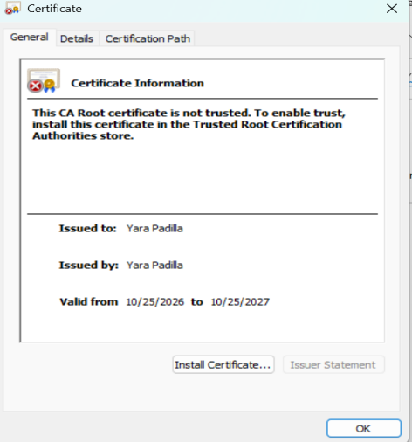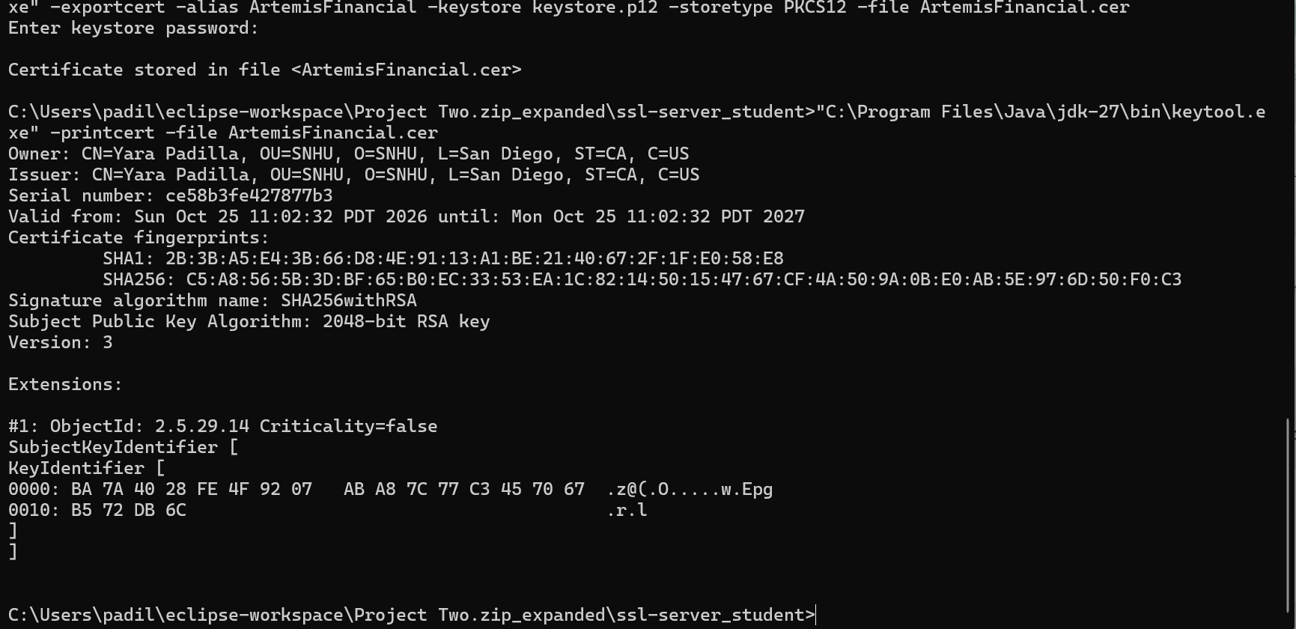

Deploy Cipher
Insert a screenshot below of the checksum verification.
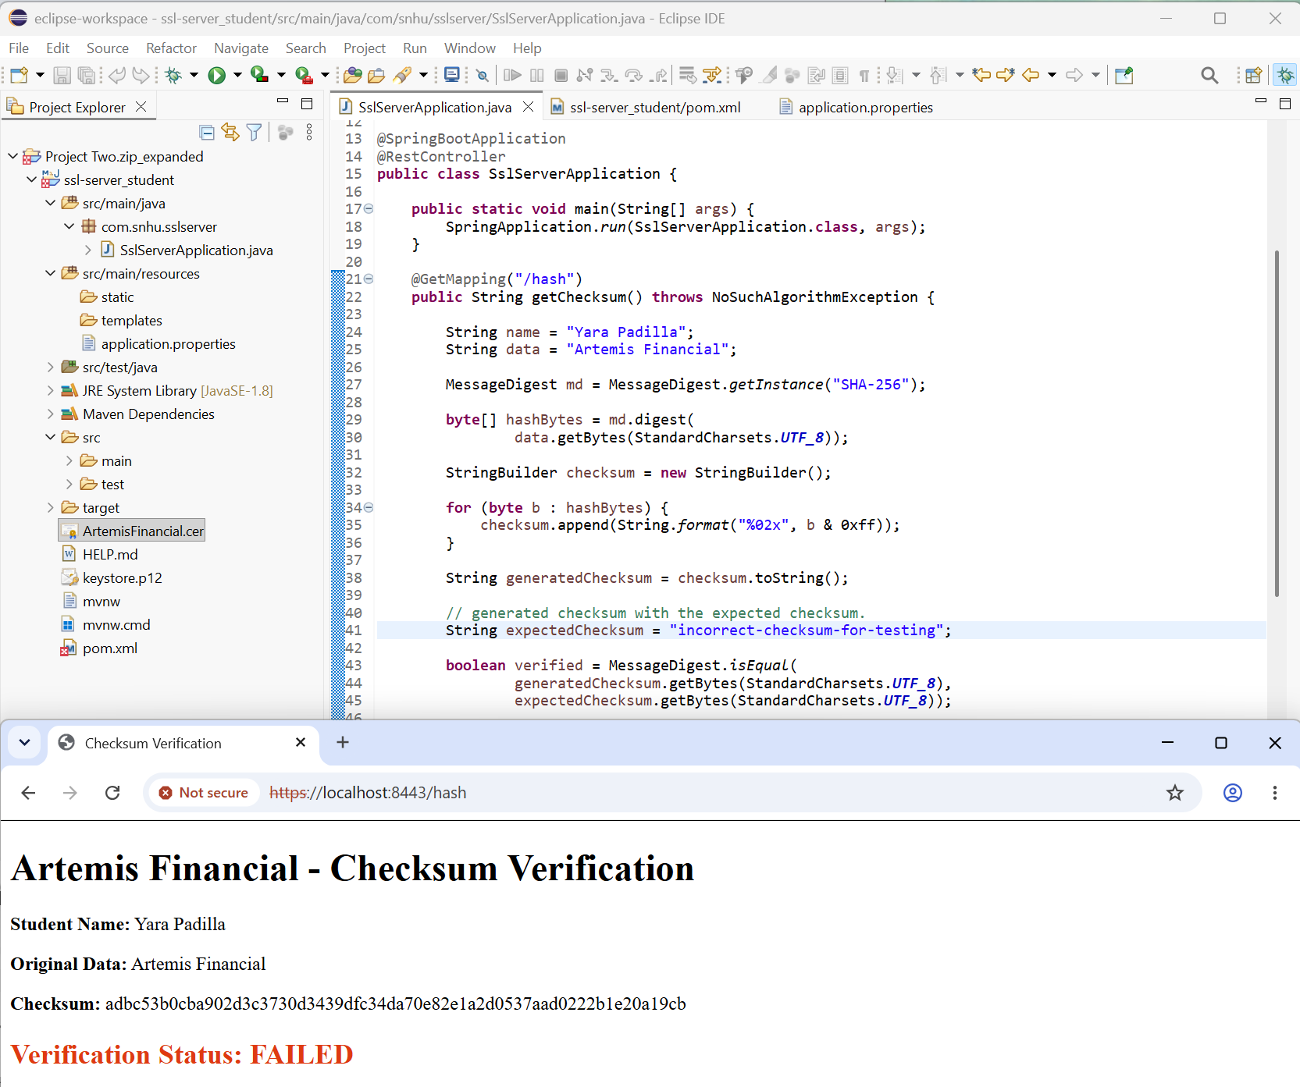
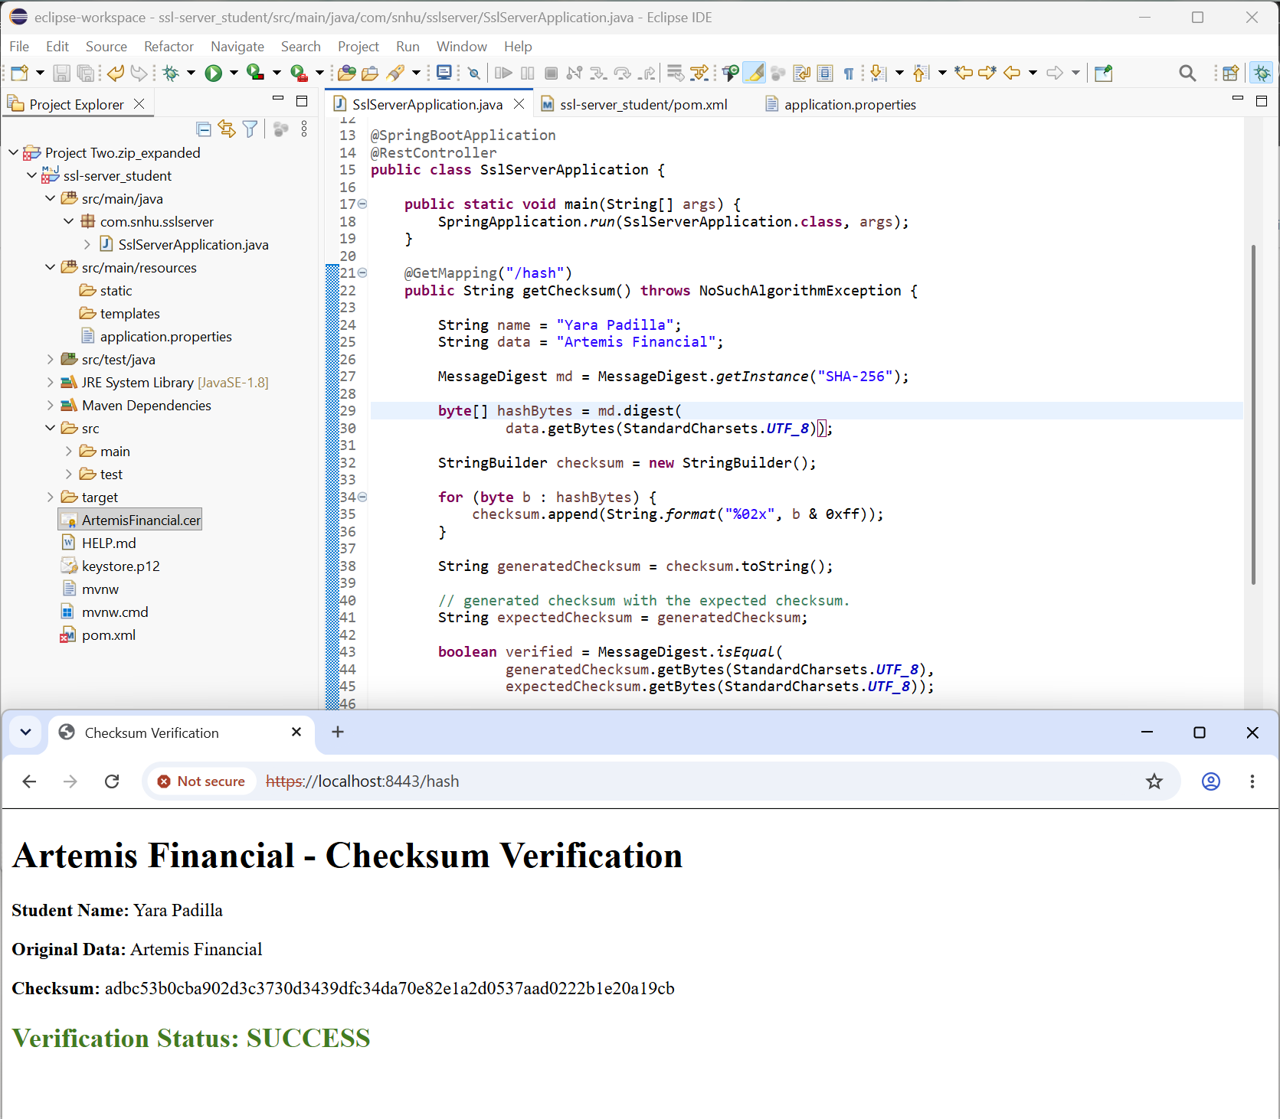

Secure Communications
Insert a screenshot below of the web browser that shows a secure webpage.
I created two self-sign certificates to secure the application. Although the second certificate included "localhost," the browser still showed a "Not secure" warning because a trusted certificate authority issued neither certificate. This helped me understand that while HTTPS encrypts communication, the browser also needs a trusted certificate to verify the connection. I tried my best to generate different scenarios, yet I wasn’t successful.
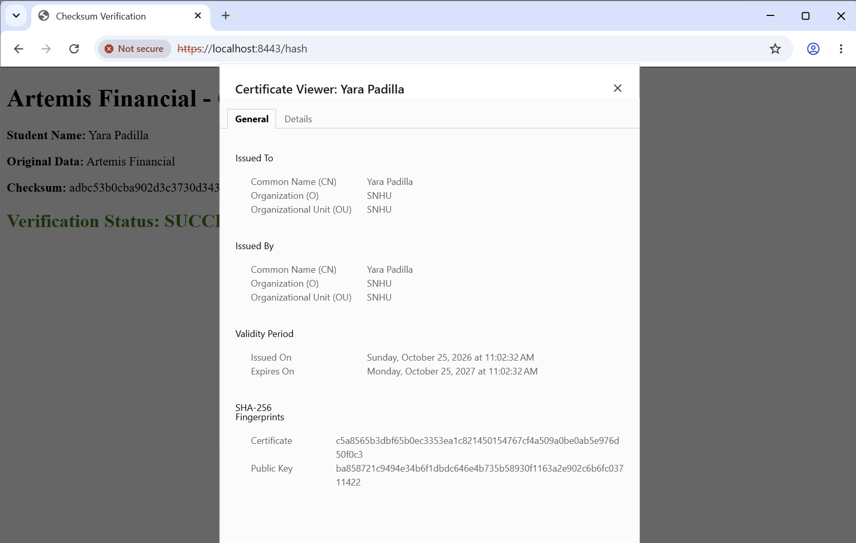
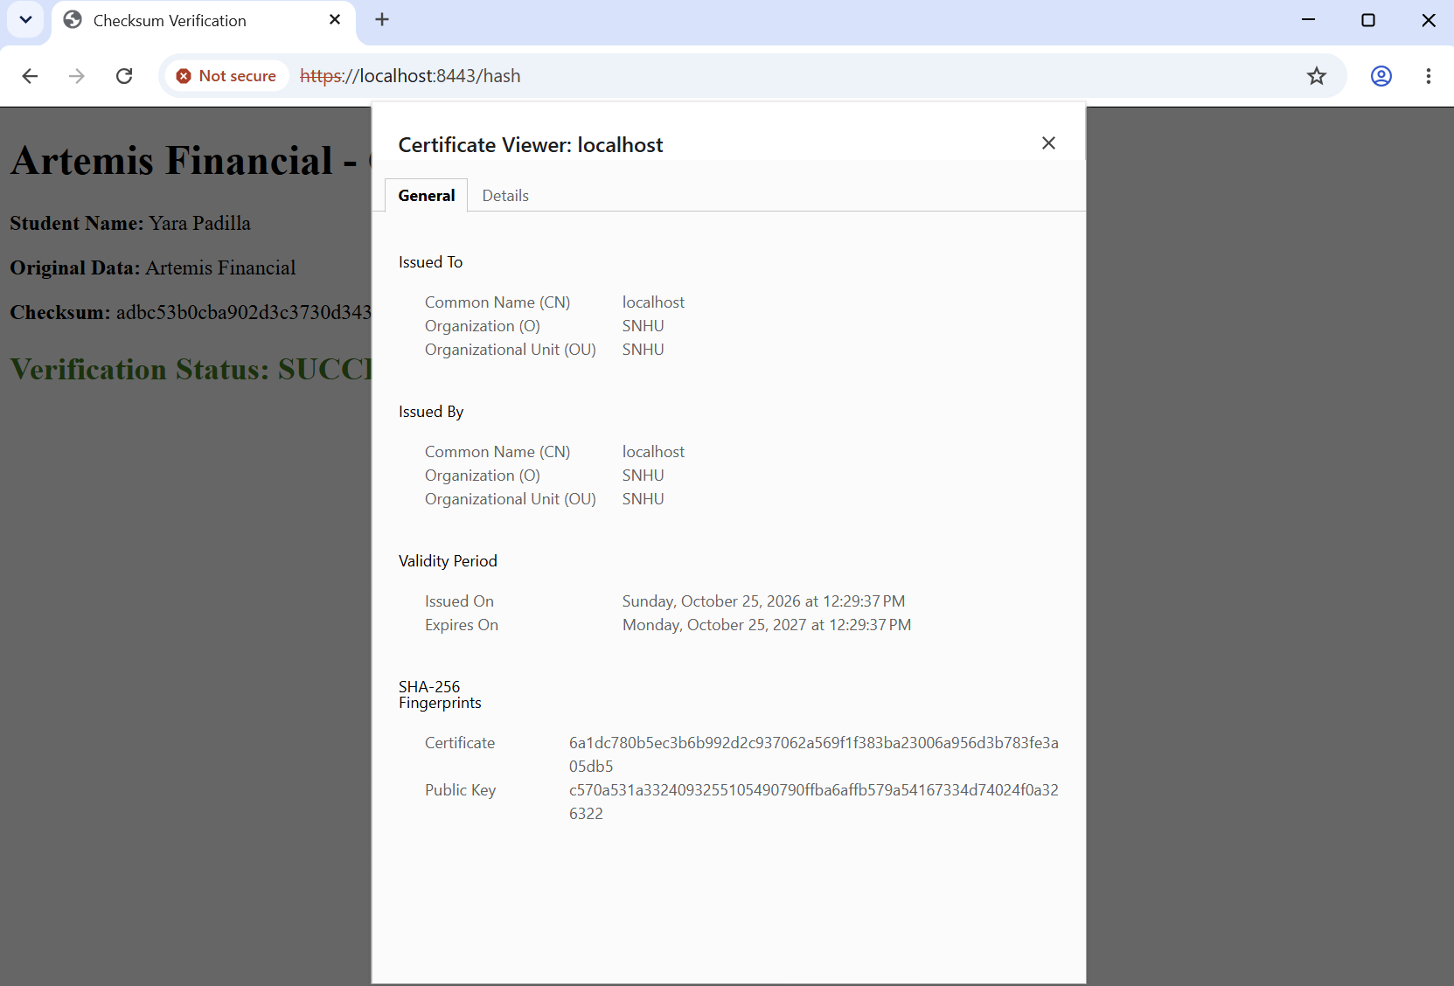

Secondary Testing
Insert screenshots below of the refactored code executed without errors and the dependency-check report
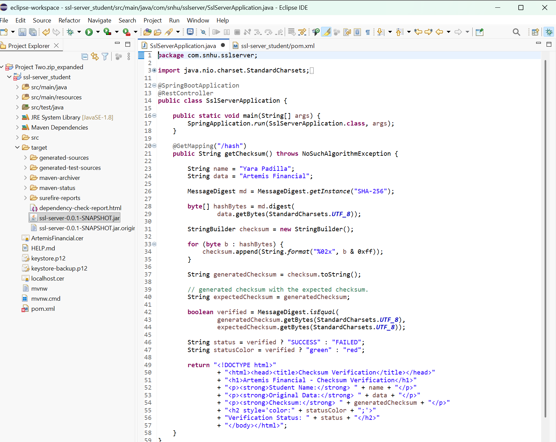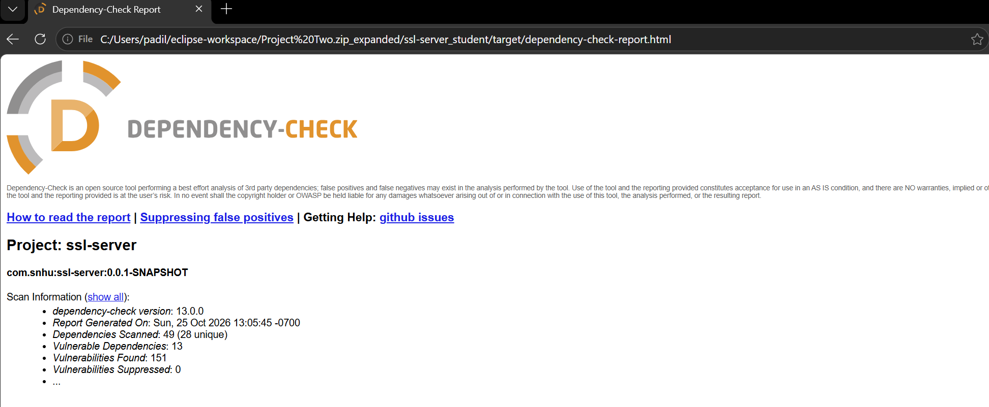

Functional Testing
Insert a screenshot below of the refactored code executed without errors.
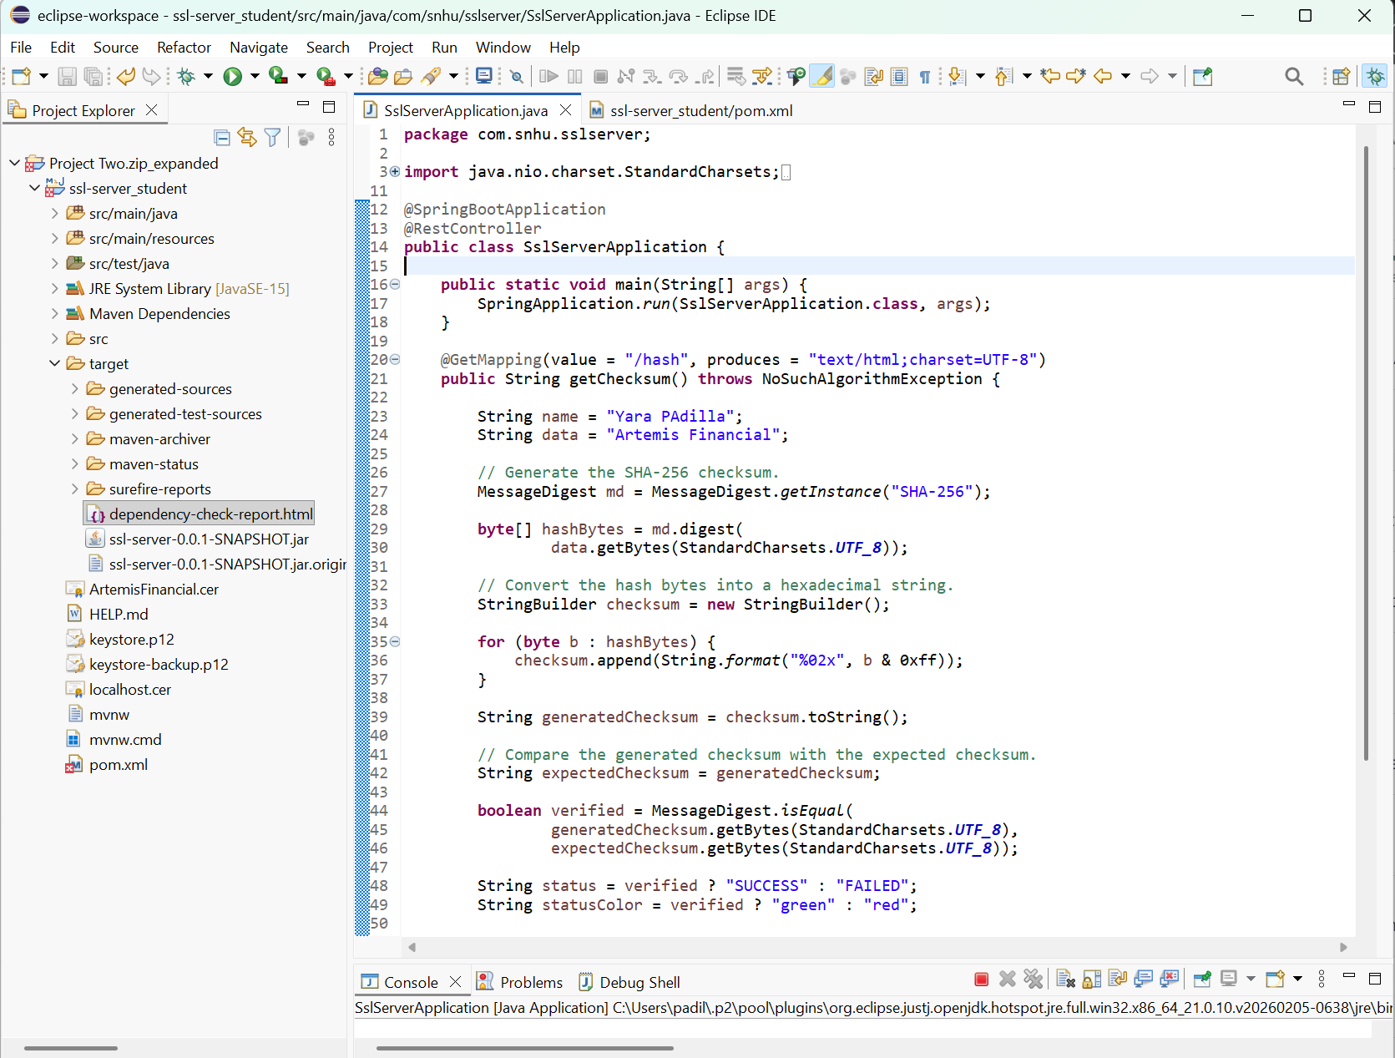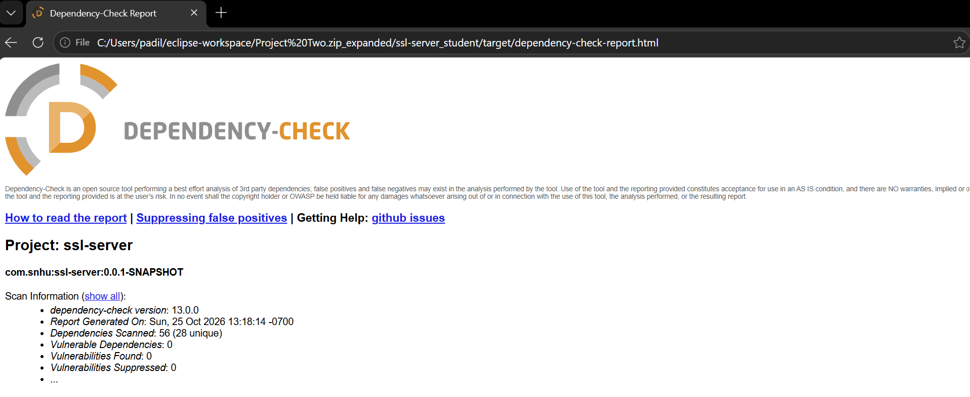
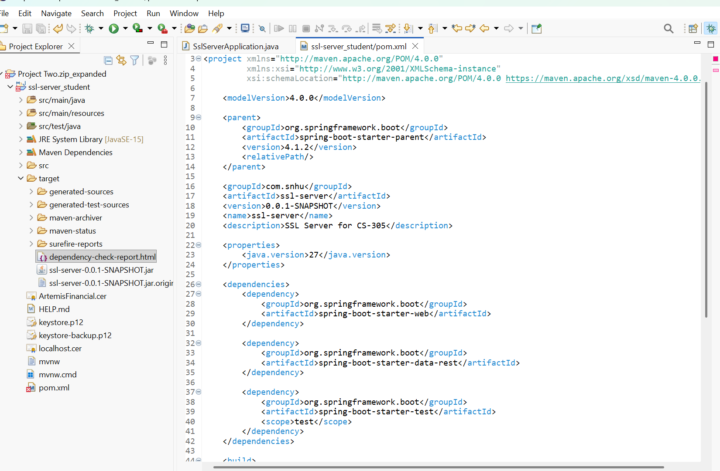

Summary

The project aimed to strengthen application security by identifying dependency vulnerabilities, reviewing Java code, and enhancing maintainability and reliability. It showed how manual code reviews, dependency management, automated vulnerability scanning, and functional testing work together to boost software security and maintainability.
- Conducted a security assessment by manually reviewing SslServerApplication.java and utilizing OWASP Dependency-Check to identify known vulnerabilities in third-party libraries. The initial scan revealed 13 vulnerable dependencies and 151 reported vulnerabilities, highlighting the risks of outdated software components.
-The updated pom.xml file reflects the following changes: the Spring Boot parent version has been changed from 2.2.4.RELEASE to 4.1.2, and the Java version property has been updated from 1.8 to 27. I kept the web, data REST, and testing dependencies, as well as the OWASP Dependency-Check plugin version 13.0.0. These updates help Maven find the right dependency versions using the new Spring Boot configuration.
- I re-ran the OWASP Dependency-Check following the configuration changes. The final report showed zero vulnerable dependencies and no reported vulnerabilities across 56 scanned entries, including 28 unique dependencies. This shows a significant reduction in reported dependency-related security risks, but it does not guarantee the entire application is free of vulnerabilities.
- I refactored SslServerApplication.java to improve readability and maintainability while keeping the SHA-256 checksum generation and /hash endpoint intact. I also fixed the HTML structure and explicitly specified the response content type and UTF-8 encoding.
- I identified a flaw in the system regarding checksum handling, where the expected checksum was obtained directly from the generated checksum. This sabotages the integrity verification process, as it allows an incorrect checksum to appear valid.

Industry Standard Best Practices

I applied industry-standard secure coding practices by manually reviewing the Java source code, identifying potential security weaknesses, and improving code maintainability while preserving the application's SHA-256 checksum functionality and /hash endpoint. I updated the Maven configuration to use Spring Boot 4.1.2 and used OWASP Dependency-Check 13.0.0 to identify known vulnerabilities in third-party dependencies. The initial scan reported 13 vulnerable dependencies and 151 vulnerabilities, while the final scan reported zero vulnerable dependencies and zero vulnerabilities across 56 scanned dependency entries.
To ensure the application's security, I preserved its functionality, improved response handling, and conducted automated vulnerability scans on the updated dependencies. I found a checksum verification flaw where the expected checksum was set directly to the generated one. This needs correction to use a trusted, independently obtained checksum. I also need to run compatibility checks and functional testing to ensure the updates don't cause regressions.
Applying these practices benefits Artemis Financial by reducing exposure to known vulnerabilities, protecting sensitive information, improving software reliability, and maintaining customer trust. Regular code reviews and dependency monitoring can also reduce remediation costs and make future maintenance more manageable. The final scan showed that the application's dependency security has improved. But I still need regular testing and vulnerability assessments to keep overall security strong.

References:

- Certera. (2023). What is a cipher? Types of ciphers in cryptography. https://certera.com/blog/what-is-a-cipher-types-of-ciphers-in-cryptography/
- Let's Encrypt. (n.d.). How it works. https://letsencrypt.org/how-it-works/
- Manico, J., & Detlefsen, A. (2014). Iron-clad Java: Building secure web applications. McGraw-Hill Education.
- National Institute of Standards and Technology. (2001, updated 2023). Advanced Encryption Standard (AES) (FIPS PUB 197, updated). U.S. Department of Commerce. https://doi.org/10.6028/NIST.FIPS.197-upd1
- Oracle. (n.d.). The keytool command. https://docs.oracle.com/en/java/javase/21/docs/specs/man/keytool.html

